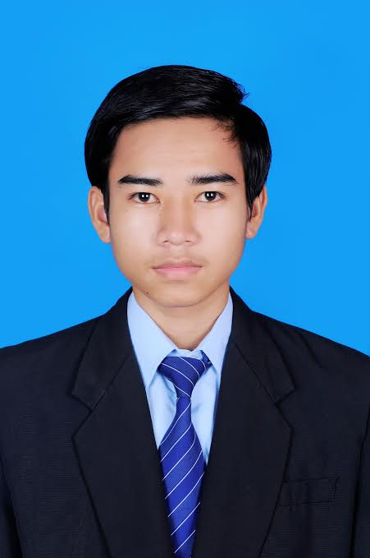

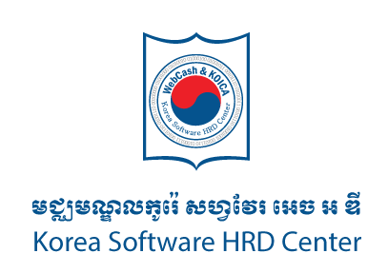

**Korea Software HRD Center Student’s Background**

**#12, St 323, Boeungkak II Commune, Toul Kork District, Phnom Penh. Cambodia.**

**Tel:(855) 23 99 13 14, Fax:(855) 23 99 14 15**

**W.** [**www.kshrd.com.kh/**](http://www.kshrd.com.kh/) **FB. Wwww.facebook.com/ksignhrd**

**CURRICULUM VITAE**

**MR. LIM CHHUNLY**

Address **:** # 09, St. G3, Sangkat Phnom Penh Thmey, Khan Sen Sok, Phnom Penh

Phone **:** 096 88 52 699

E-mail **:**  limchhunly.mail@gmail.com

**1. PERSONAL DATA**

Sex **:**  Male

Date of Birth  **:** March 18, 1994

Place of Birth **:**  Kampong Leng District, Kampong Chhnang Province, Cambodia

Nationality **:**  Khmer

Marital Status **:**  Single

Health Situation **:** Excellent

**2. HRD CENTER TRAINEE**

|  |  |  |
| --- | --- | --- |
| Course | Duration | Training Time |
| Basic | April,1st – September,30th 2016 | Mon-Fri, 8 hours per day |
| Task Achievements | | |
| JAVA | WEB | SPRING |
| * J2SE (Basic Java and OOP concepts) * J2EE (JSP, JSTL, Servlet and MVC pattern) * Database (Oracle, PostgreSQL) | * HTML * CSS * BootStrap * JavaScript * jQuery * AJAX * JSON * AngularJS | * Spring MVC 4 * Spring JDBC * Spring RESTful API * Spring Security |
| Advanced | November,1st 2016 – February,28th 2017 | Mon-Fri, 8 hours per day |
| Task Achievements | | |
| Delphi | | |
| * Object Pascal Programming * Web Scraping Concept * Web Security Analysis * Real Project Implementation ( EZCodeGenerator ) | | |

**3. ACADEMIC BACKGROUND**

|  |  |  |  |  |  |
| --- | --- | --- | --- | --- | --- |
| Institution Name | Location  (Province/City) | Year Attended | | Major | Degree/Diploma |
| From | To |
| Royal University of Phnom Penh | Phnom Penh | 2013-2017 | | Computer Science | Bachelor Degree |

**4. OTHER TRAINING**

|  |  |  |  |  |  |  |
| --- | --- | --- | --- | --- | --- | --- |
| Institution Name | Location | Year Attended | | Course Title | Certificate | |
| From | To |
|  |  |  | |  |  |  |

**5. LANGUAGES**

|  |  |  |  |  |
| --- | --- | --- | --- | --- |
| **Languages** | **Writing** | **Speaking** | **Listening** | **Reading** |
| Khmer | Good | Good | Good | Good |
| English | Good | Good | Good | Good |
| Korean | Fair | Fair | Fair | Fair |

**6. REFERENCES AND AVAILABILITY**

**Dr. Kim Tae Kyung**

Position **:** Director of Korea Software HRD Centre

H/P **: 017 528 169**

Email **:**  misoh049@gmail.com

**Mr. Chen Phirum**

Position **:** Deputy General Manager at Korea Software HRD Center/KOSIGN Co.,Ltd

Phone **:**  **077 77 123 6**

Email **:** [phirum.gm@gmail.com](mailto:phirum.gm@gmail.com)